Catalog
Chapter 1- Install and Uninstall 1
1. Software instal 1
2. Software uninstall 3
Chapter 2- Network setting 4
Chapter 3- Edit the Program 5
1. Software Interface 5
2. Program Stucture 6
3. New Screen 6
4. Add New program 8
5. Add Custom Area 9
6. Add source files: Video, Photo, Animation, Excel 10
7. Add Text 12
8. Add Single Line Text 13
9. Add Clock 14
10. Add Time 17
11. Add Temperature 19
12. Add Animation 20
13. Add Humidity 21
14. Add Neon 22
15.Program Preview and Save 23
16. Program Import and Export 23
17. Add 3D Text 24
18. Add Weather 25
Chapter 4- Program Update 27
1. Using Cloud Server Updating 27
2. Using U-disk Updating 28
3. U-disk Expanding Programs 28
Chapter 5- Systerm Setting 30
Chapter 6- Systerm Control 31
1. Device Bind 31
2. Brightness Adjustment 31
3. Time correction 33
4. Screen Testing 34
5.Firmware Updating 34
6. Network Information Setting 35

Chapter 1- Install and Uninstall

1. Software Install
1）Open the CD, double click the icon HDPlayer.X.X.X.X.exe(Like：HDPlayer 3.2.97.0.exe). Select the installer Language, click “ok”.

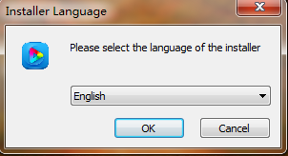
Fig. 1-1 Installer Language

2）Installation Interface, Click “next”.
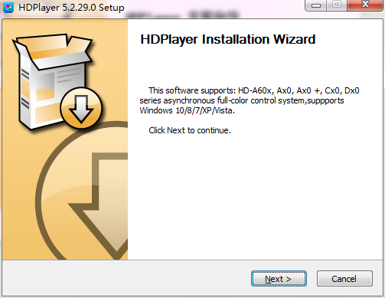
Fig. 1-2 Installation Guide

3）Confirm the Installation type, Click “Next”.

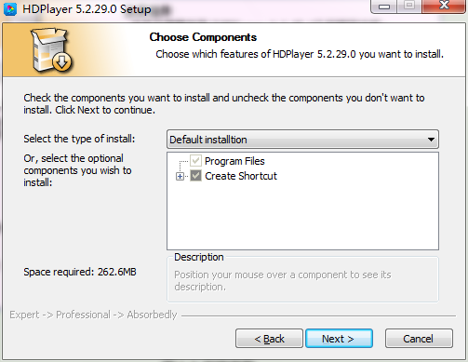
Fig.1-3 Installation type

4）Choose Installation Path, Click “Install”.
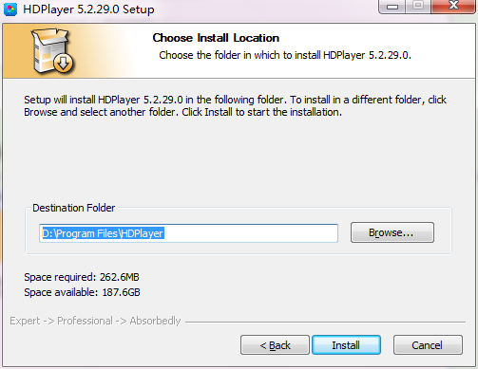
Fig. 1-4 Installation Path

5）Click “Finish”.
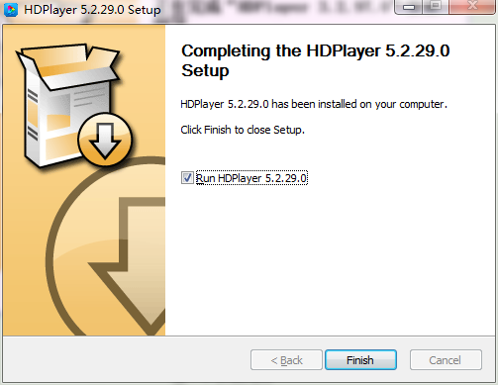

Fig. 1-5 Finish Installation

2. Software Uninstall
“Start”→ “All Programs”→“HDPlayer”→“Uninstall HDPlayer”

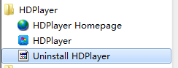
图1-6 Software Uninstall

Chapter 2- Network setting

The controller can connect to the computer directly. It can also connect to the computer via the Router. No need to do network setting.

When connected with computer, the network port (The Green light always flicker, the orange light bright), then wait for few seconds (Windows XP need more than 50Seconds, Window7 only need 40Seconds).When the right corner of computer show Network normal (see below), it means it have been connected of network, ------then open the software HDPlayer, it will find the controller ID automatically.
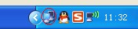Or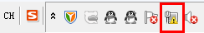
Fig. 2-1 Network normal connected
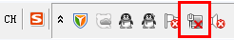
Fig. 2-2 Network abnormal connected

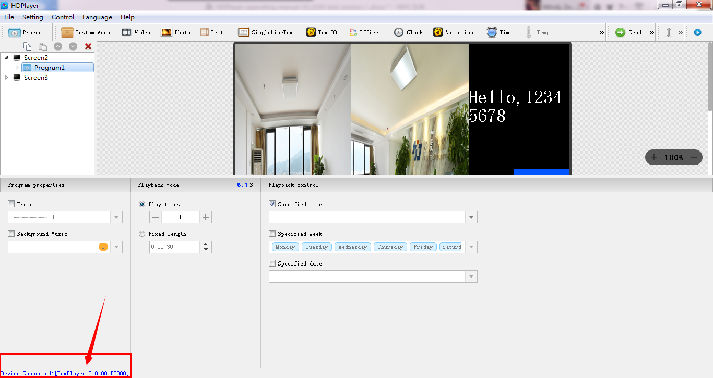
Fig. 2-3 Device Found
If the cards connect to the computer via the Router, then the computer can control all the cards at the same time.

Chapter 3 Edit the Program

Software Interface
There is two parts in the software: play window and edit window.
Play window（what will show on the display）：Use for showing the videos, photos and texts etc.
Edit window: Include the menu bar, tool bar, tree area, attribute area and status bar.
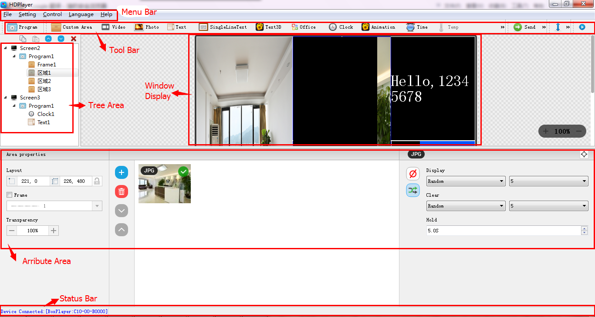
Fig.3-1 Software Interface
Menu Bar：Include files, setting, control, language and help.
Tool Bar: Include program, area, source file, text, document, clock and timer etc.
Attribute Area: Showing each section’s information; Set the frame, the playing effect and playing time.
Tree Area: Showing all the contents of this program.
Status bar: Detecting the card information.

2. Program Structure
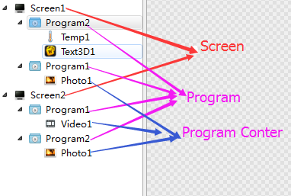
Fig.3-2 Program Structure

3. New Screen
Select the menu bar 【File】 → 【New】 option or press Ctrl + N key to create a new display, and can add multiple display at the tree area. To delete the display, select the display, and then press Delete or right-click to select the Delete option to delete the display.
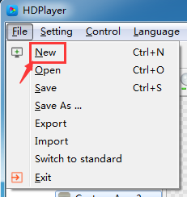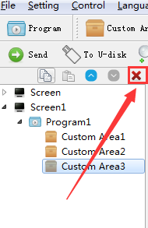

1）Setting the play window
Click【Setting】→【Screen Parameter Setting】, into the parameter setting interface：(The width and Height it is led display size)
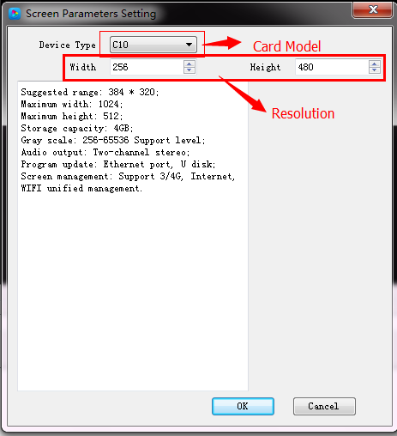

Fig. 3-3 Screen Parameter Setting
The default is use “hardware settings" read back the parameters of the control card;
When you not select the "hardware settings", you can set the device model, module type, width and height;
If the control card is connected to the computer, the system will show the control card ID in the "Select Device" option and select the device automatically.
The Software supports "display" rename, delete, create, adding programs, send, close and other operations.

2) Display properties
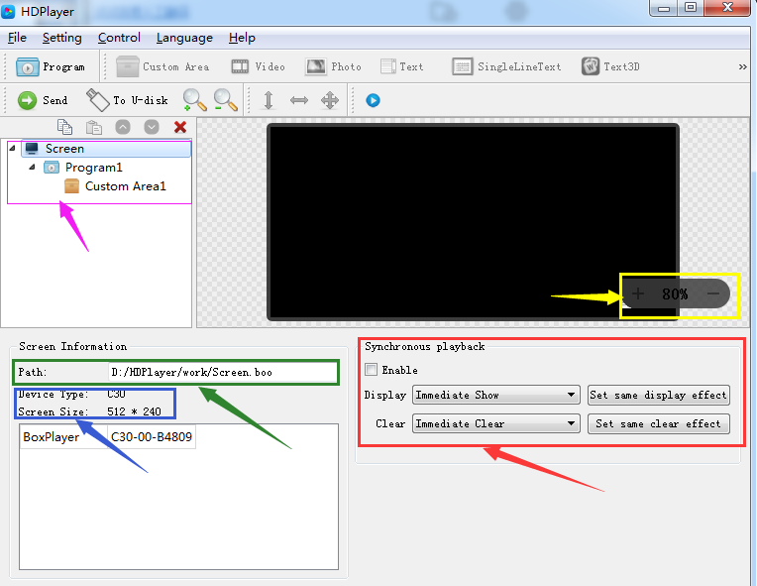
Fig. 3-4 Display properties

4. Adding programs
Click the "program" icon on the toolbar to create a new program; you need to add a display before you add a program. One display can add multiple programs, click the shortcut bar "delete" button can delete the "program".
Users can right-click to rename, delete, add, copy, and move the "program".
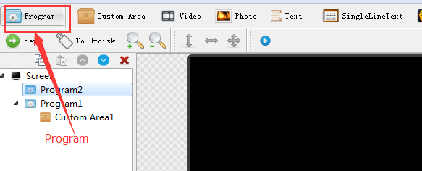
Fig. 3-5 adding new programs
- Program attribute
In the program attribute, we can set the play time, duration, what time to play and play background music and borders; also can choose a number of background music, the setting has to be sent to the control card so it can take effect.
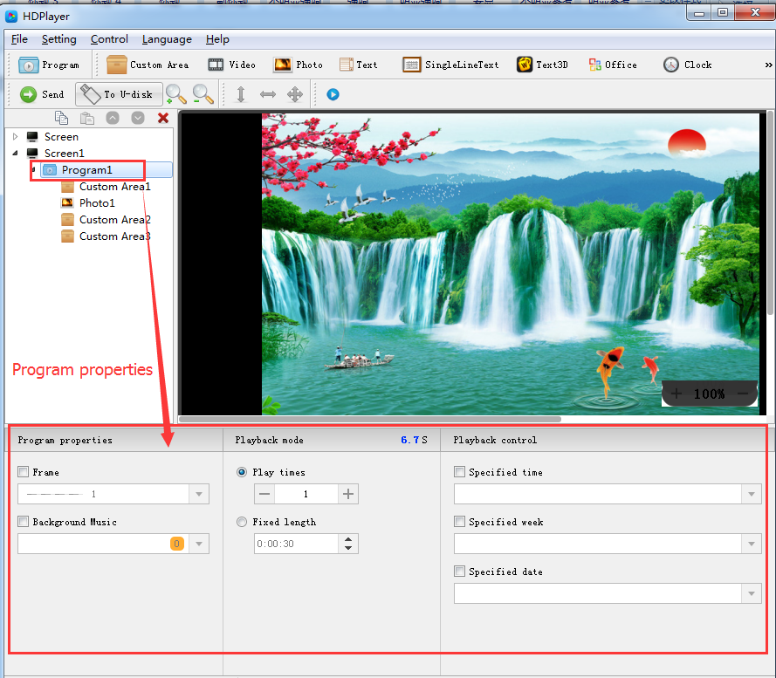
Fig. 3-6 Program attributes
"Specified time" is the program playing time, "playing time" means play at a certain time or time period.

5. Add Custom Area
Click the "Custom Area" icon on the toolbar to create a new area (a blue border area appears on the analog display). It needs to add a program before you add a zone. You can add multiple areas under a program.

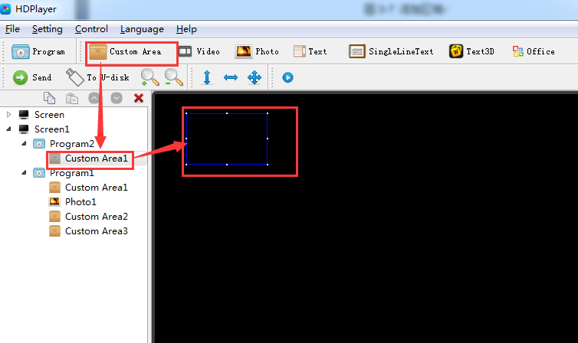
Fig. 3-7 Add Custom Area
Right-click the "area" can rename, delete, and add, copy, move and other operations.

1）Area attribute
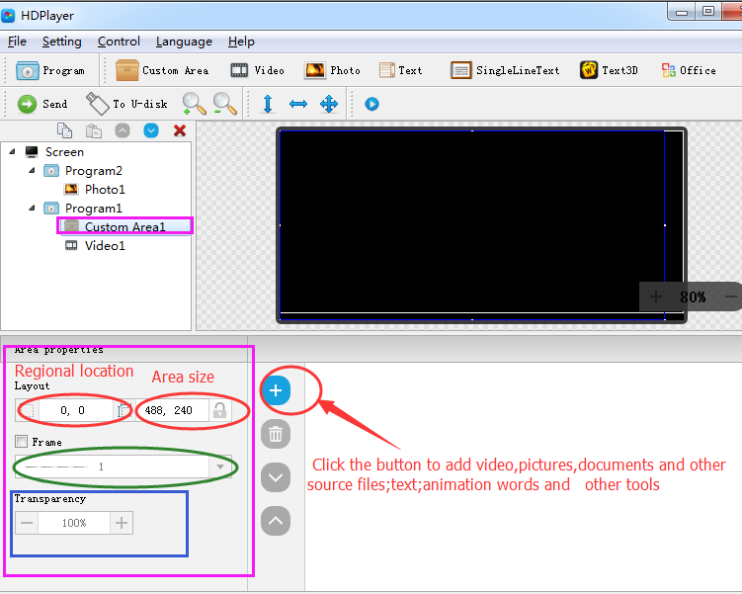
Fig. 3-8 Area attributes
Change the location and size of the area:
- Set the X / Y coordinate, the width and height
- Drag the area or stretch in the playback window
- Choose this option
You can also set the area border and the transparency.

6. Add video, pictures, animation, forms and other source files
Click the corresponding icon in the toolbar to add video, picture, animation, excel, Word, PPT and other source files, to delete the "source file", click the shortcut bar "delete" button.
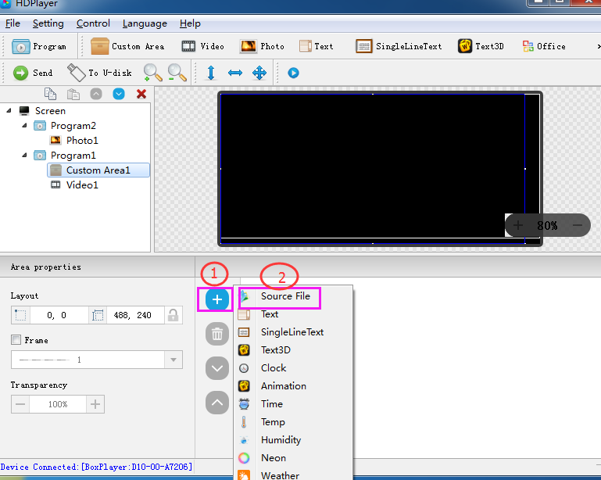
Fig. 3-9 Add source files
- video attributes
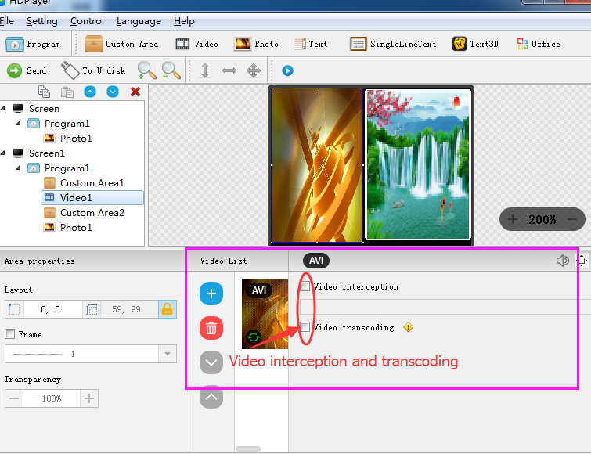

Fig. 3-10 video attributes

2) Photo properties
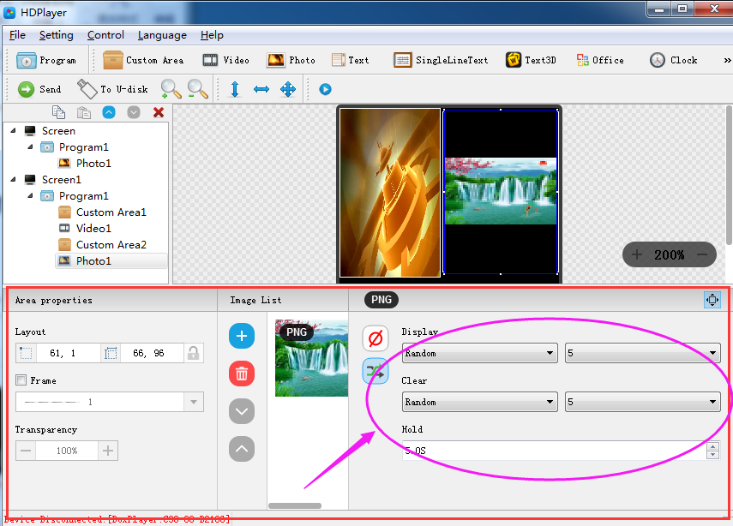
Fig. 3-11 Photo properties
We can set the picture display effects, display speed and the time of the displays and clear.

3) Gif animation properties
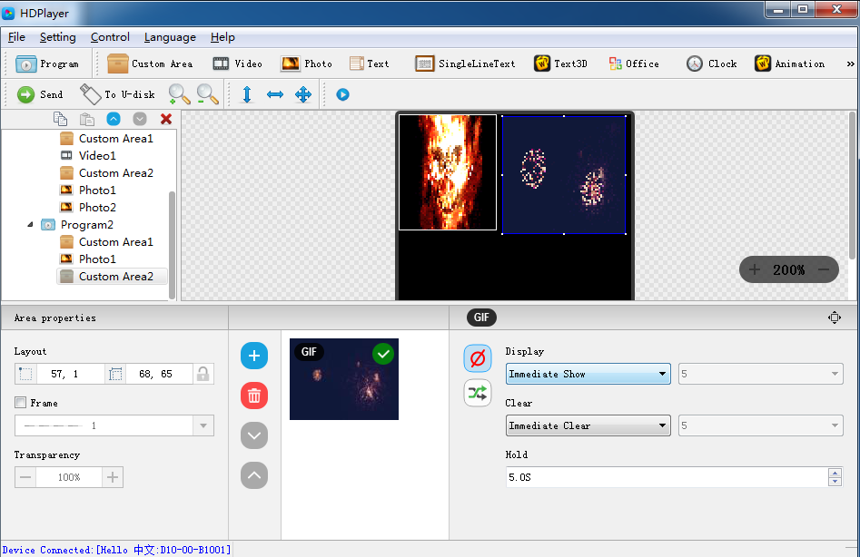
Fig. 3-12 Gif animation properties
We can set the picture display effects, display speed and the time of the displays and clear.

4) Excel、Word、PPT properties
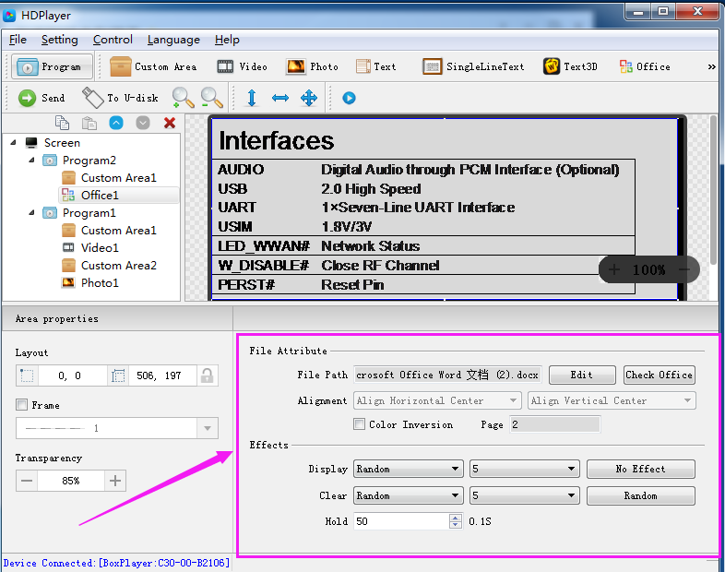
Fig. 3-13 File properties
When you add a document, you need to install a software in Office 2007, Office2010, WPS (software version 5.1.15.0 or later version can support WPS), support Word, Excel, PPT and other formats, you can set the document display effects (40 kinds of display and clear Screen effects), display speed, display and the text color reversal, Excel documents can be set to align (6 in the alignment).

7. Add multiple lines Text
Click the "text" to add multiple lines text, to delete the "multi-line text", click the shortcut bar "delete" button.
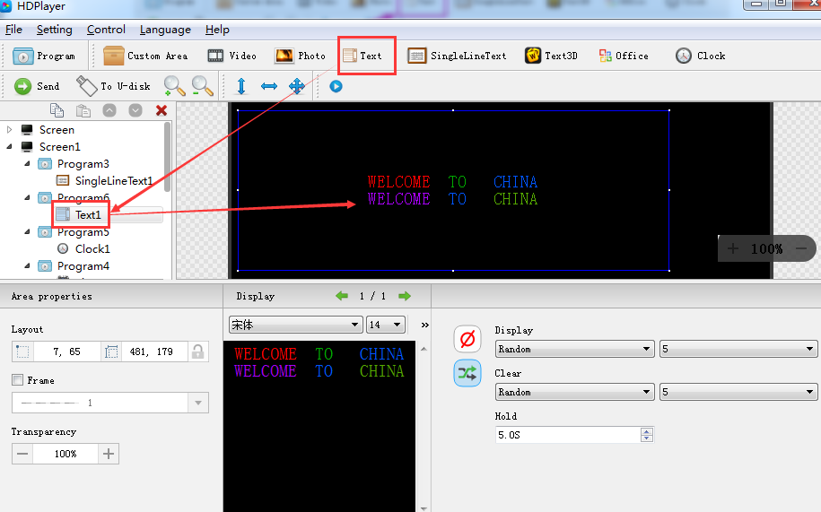
Fig. 3-14 Add Text

1) Text attributes
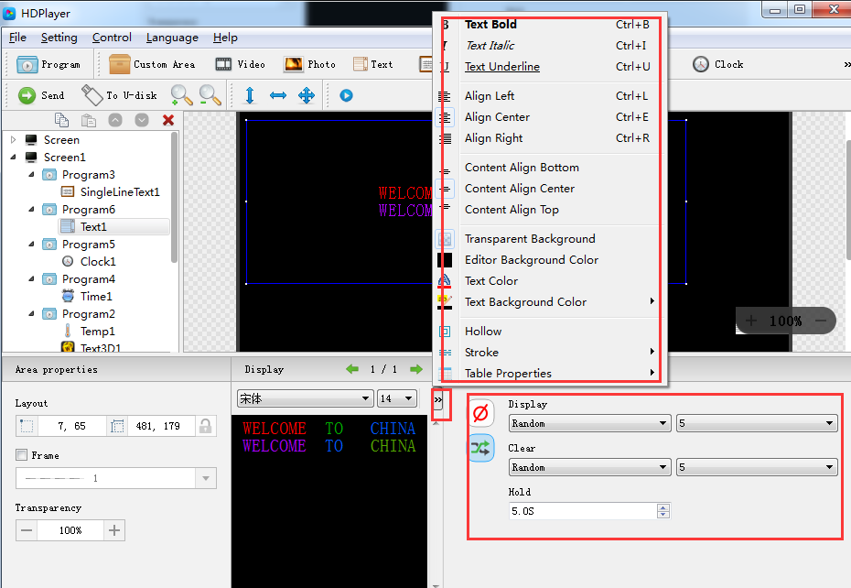
Fig. 3-15 Text attributes
It can set the text display effects (40 kinds of display and clear screen effects), display speed, the time of display and clear screen and text editing, it can also import Word, TXT, RTF and other formats of text;

8. Add Single Line Text

Click the "single line text" icon on the toolbar to add a single line of text, click the "Delete" button to delete "single line text".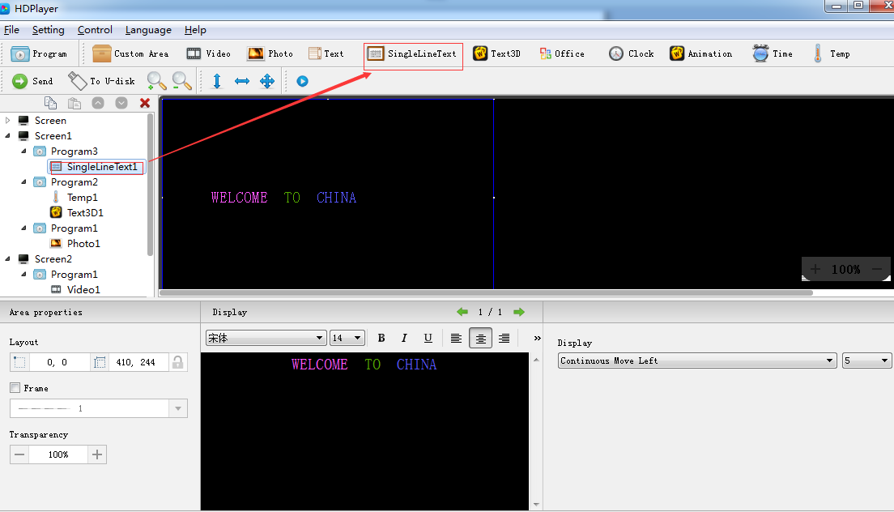
Fig. 3-16 Add Single Line Text

1) Add Single Line Text attributes
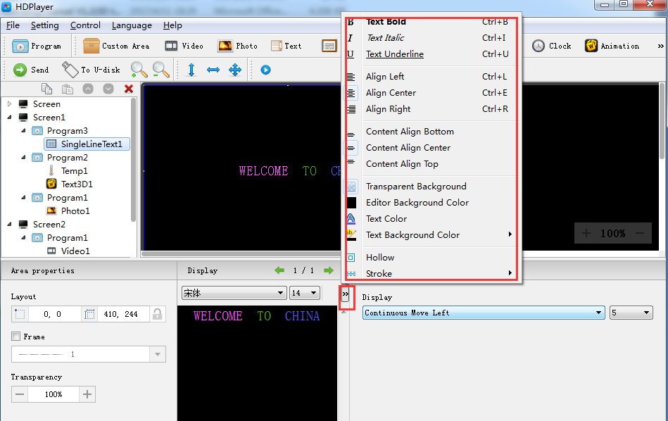
Fig. 3-17 Single Line Text attributes
Support "ordinary effects" and "continuous movement" two special effects, "ordinary effects" can set a single line text display effects (40 kinds of display and clear screen effects), display speed, the time between display and clear screen and the text edit; "continuous movement" can set continuous left or continuous right shift, whether the first connected, playback speed, playback time, playback times, etc.,

9. Add Clock
Click the "Clock" icon on the toolbar to add a clock, click the "Delete" button to delete "clock".
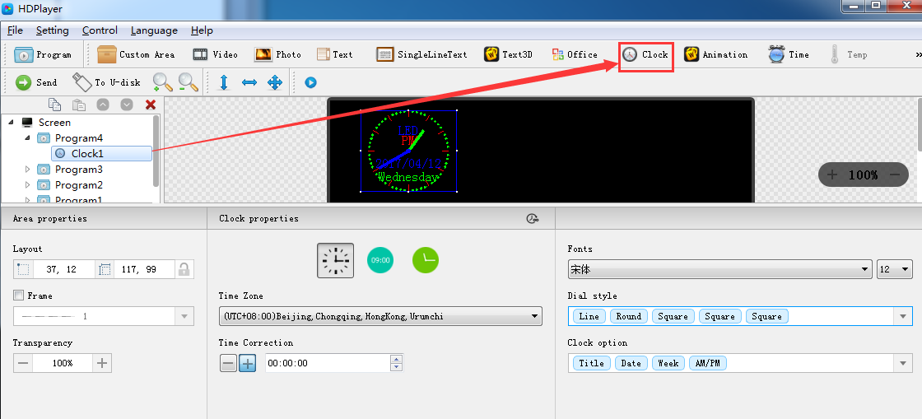
Fig. 3-18 Add Clock
1）Clock attribute
Support "analog clock" "digital clock" "picture clock" three clock types. It can set different time zones; the time can be corrected if there is a deviation. We can set description text, spacing, font type, and font size, etc.
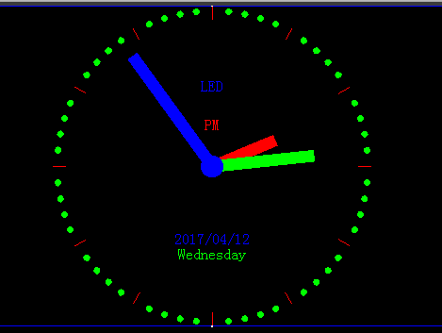
Fig. 3-19 Analog clock display
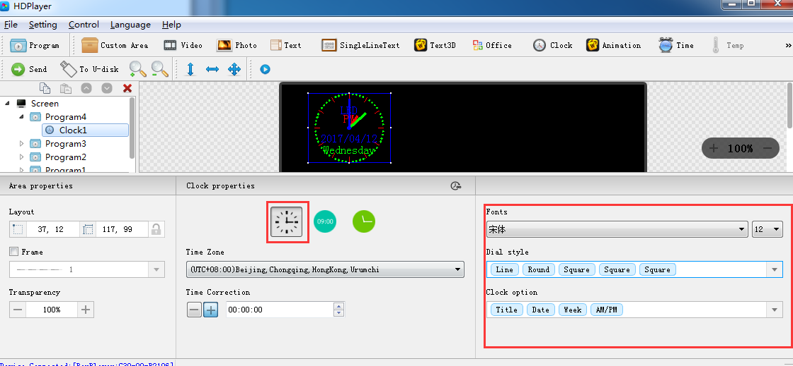
Fig. 3-20 Analog clock attribute
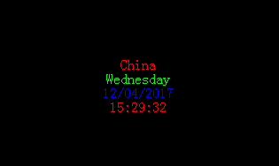
Fig. 3-21 DIGITAL CLOCK DISPLAY
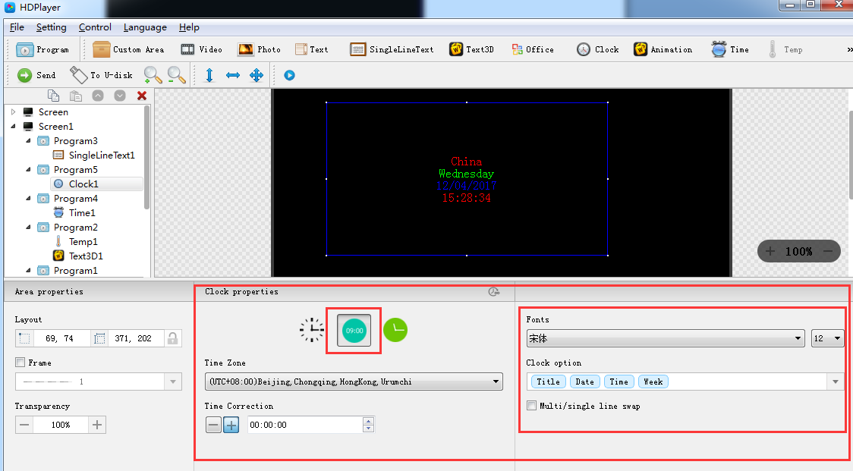
Fig. 3-22 DIGITAL CLOCK ATTRIBUTES
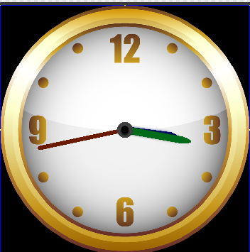
Fig. 3-23 PICTURE CLOCK DISPLAY
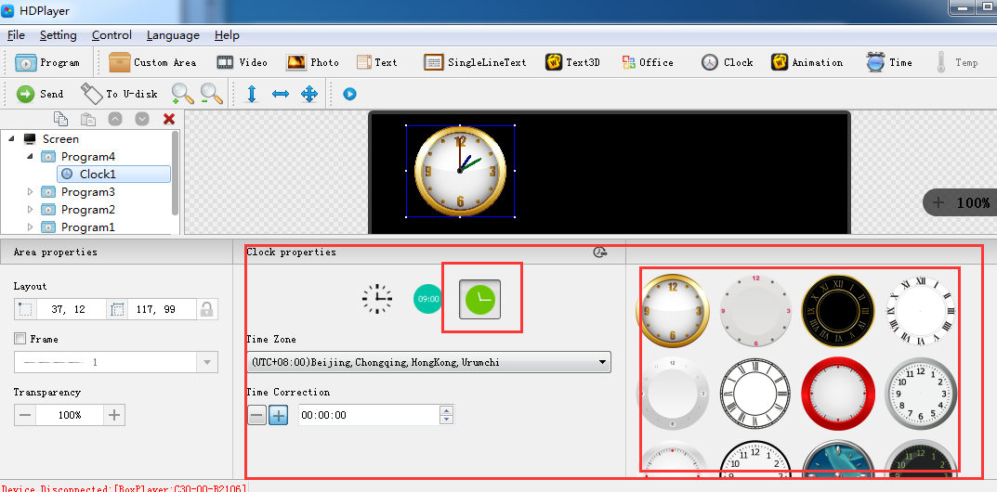
Fig. 3-24 PICTURE CLOCK ATTRIBUTES

10. Add Time
Click “Time” icon to add timer, click the "Delete" button to delete "time".
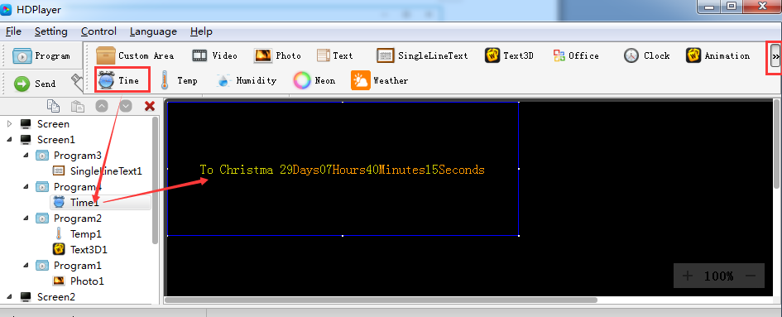
Fig. 3-25 Add Time

1) Time attribute
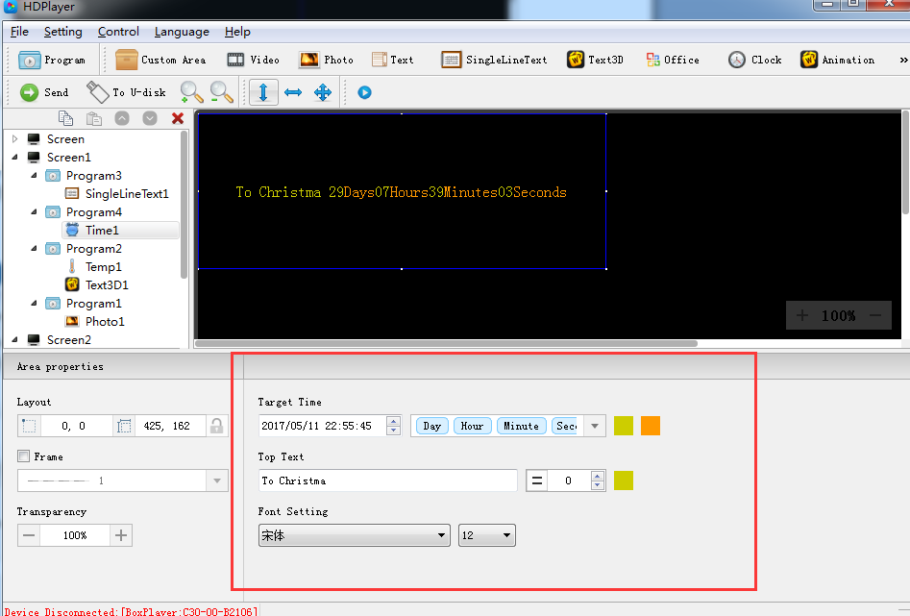
Fig.3-26 Time attributes
We can set timing mode, display mode, goal time, spacing, font type, font size, color etc.

11. Add Temperature
Click Temperature icon to add this mode, click the "Delete" button to delete "tem".
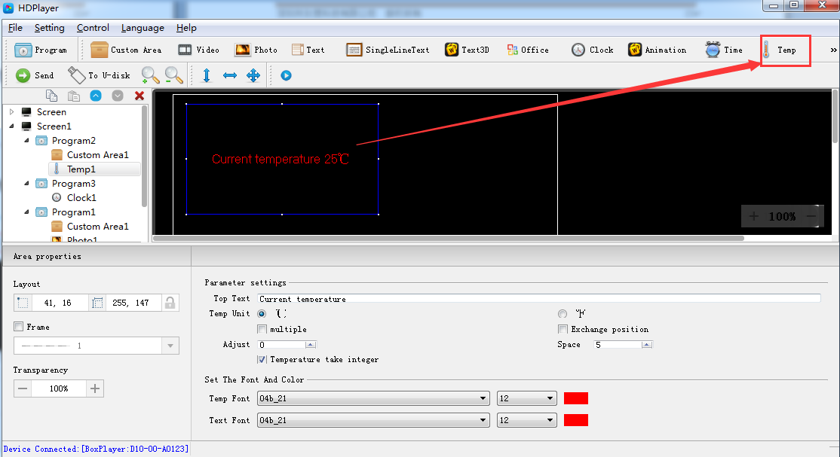
Fig. 3-27 Add Temperature
Notice: temperature sensor need to be welded on control card to ensure a correct temperature value show on the led screen.

- Temperature Attribute
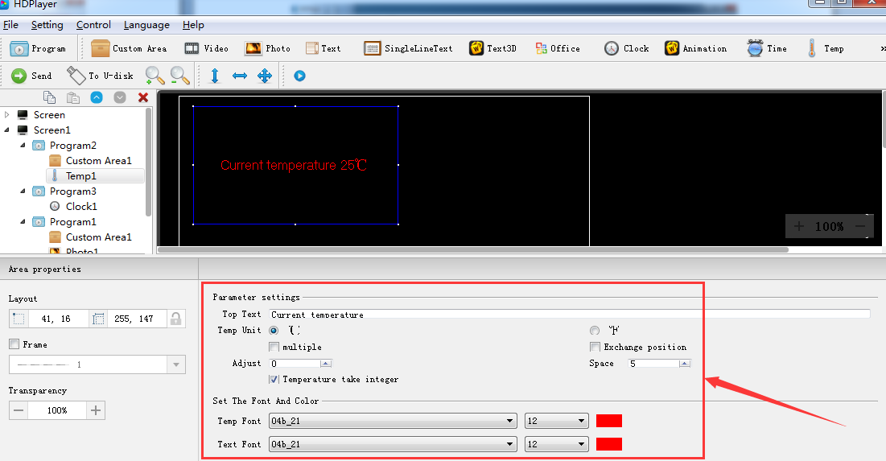
Fig. 3-28 Temperature Attribute
Support setting the font size, color, temperature unit etc.

12. Add animation characters
Click animation character icon to add this mode, click the "Delete" button to delete this item.
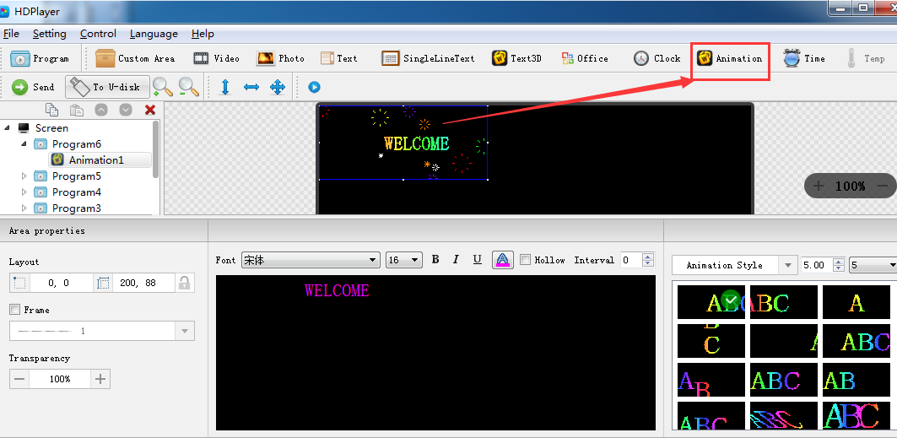
Fig. 3-29 Add animation characters

1）Animation characters Attributes
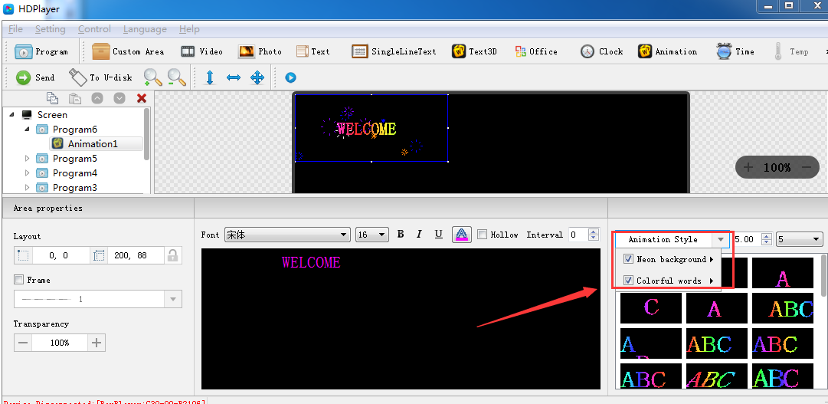
Fig.3-30 Animation characters Attributes
Support setting the font description, font color, font special effect, special effect speed etc.

13. Add Humidity
Click “Humidity” icon to add this mode, click the "Delete" button to delete this item.
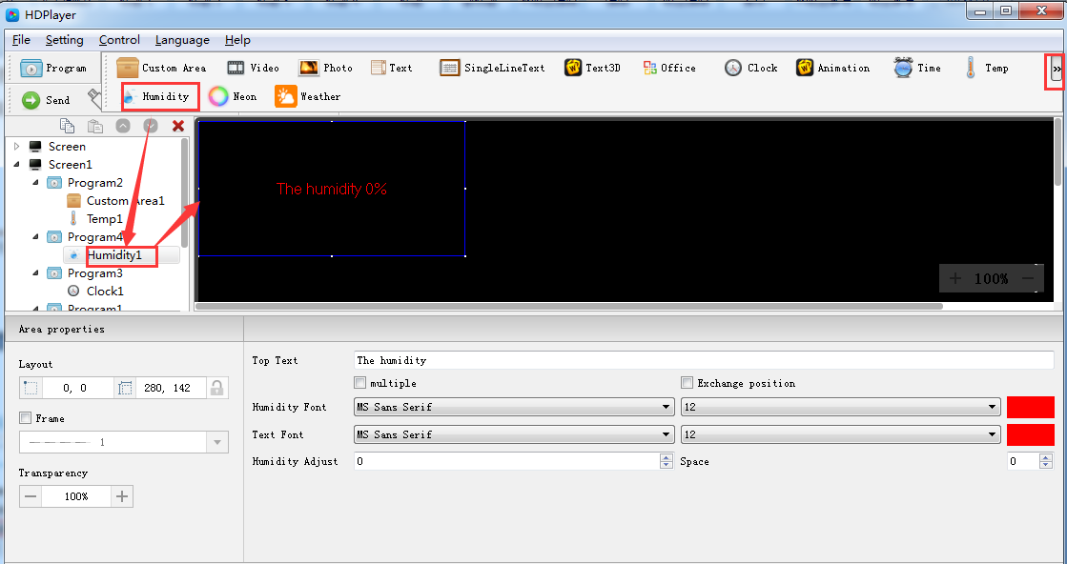
Fig. 3-31 Add Humidity
Notice：Humidity sensor need to be welded on control card to ensure a correct humidity value show on the led screen.

1）Humidity Attribute
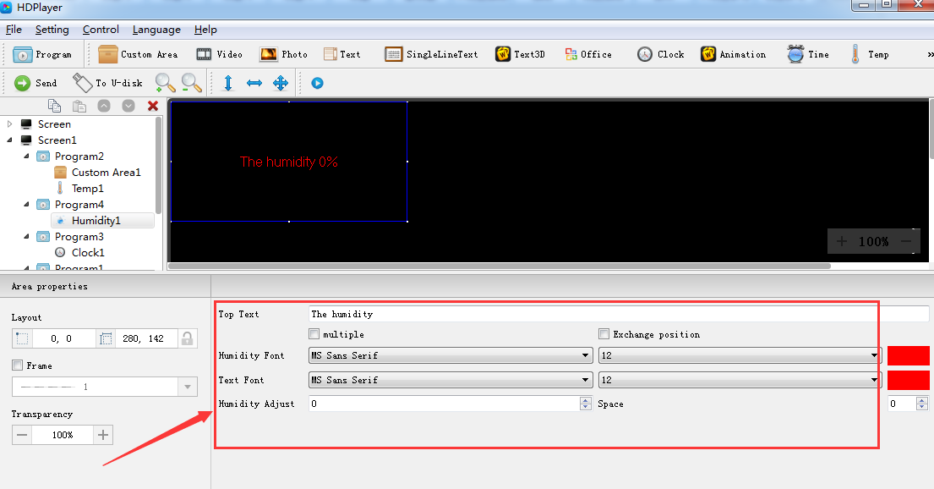
Fig. 3-32 Humidity Attribute
Support setting the font size, font color, humidity unit etc.

14. Add Neon
Click “Neon” icon to add this mode, click the "Delete" button to delete this item.
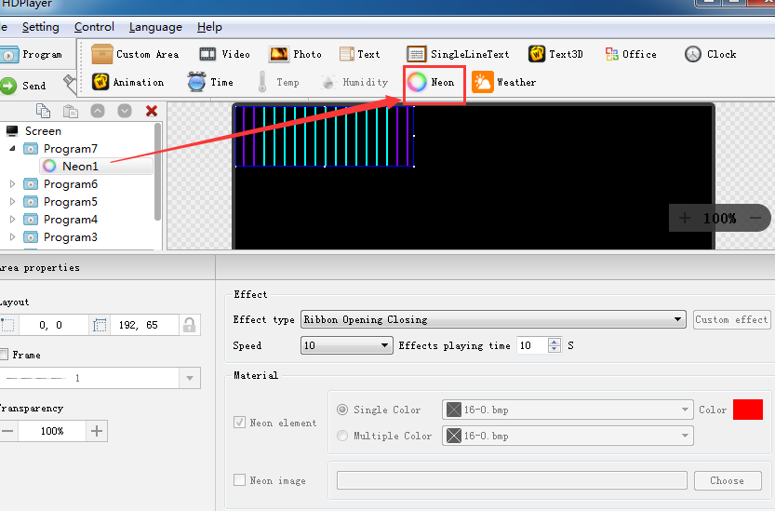
Fig. 7-33 Add Neon
- Neon Attribute
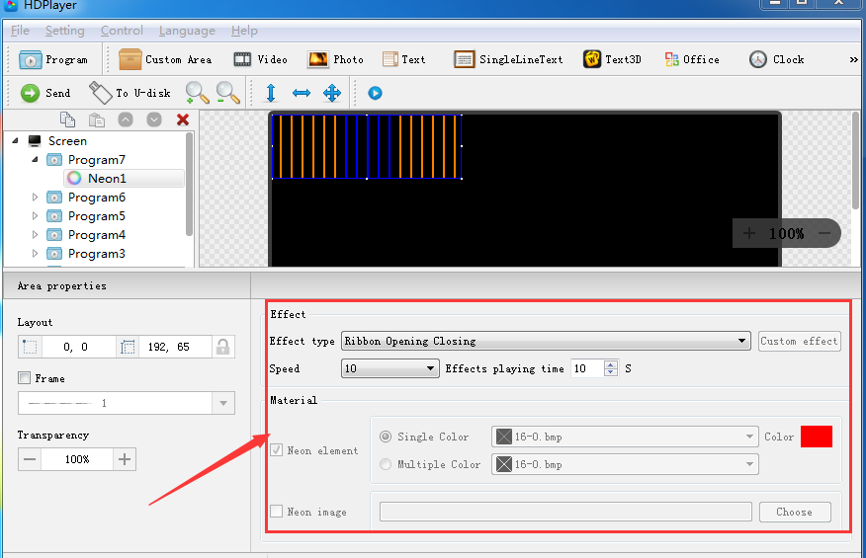
Fig. 3-34 Neon Attribute

15. Program Preview & Save
1) Program Preview
After finishing editing program, click to play, click to pause, and click to stop.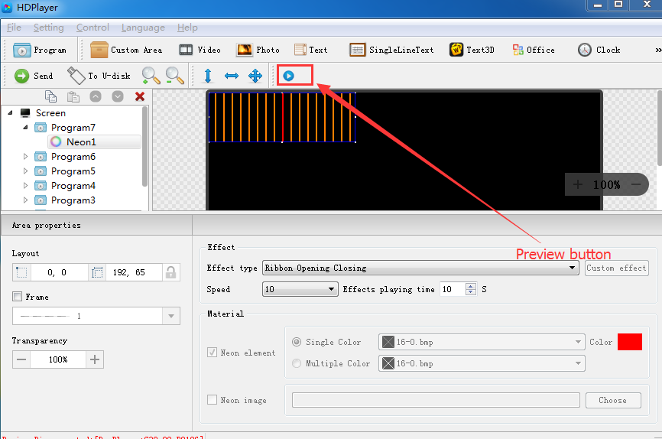
Fig. 3-35 Program Preview
Play: Program could not be edited while the screen is under a loop playback;
Pause: Program could not be edited while the screen is on pause status.
Stop: Screen will display the contents before operating, back to editing status.
2）Program Saving
Choose【File】→【Save】, or press “Ctrl” and “S”, edited program will be saved on a default file named work, file name will be “screen name. boo”, users can choose 【File】→【Open】for using.
Choose【File】→【Save as】, users can choose the saving location and set the file name, and then open to use at next time.

16. Import & Export Program
Choose【File】→【Export】, export the edited program to specified directory, for the next using in different computer.
Choose【File】→【Import】, import the exported program into software.
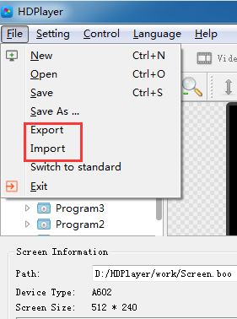
Fig. 3-36 Import & Export Program

17. Add 3D Text
Click “3D Text” icon to add 3D subtitle; click “delete” button to delete it.
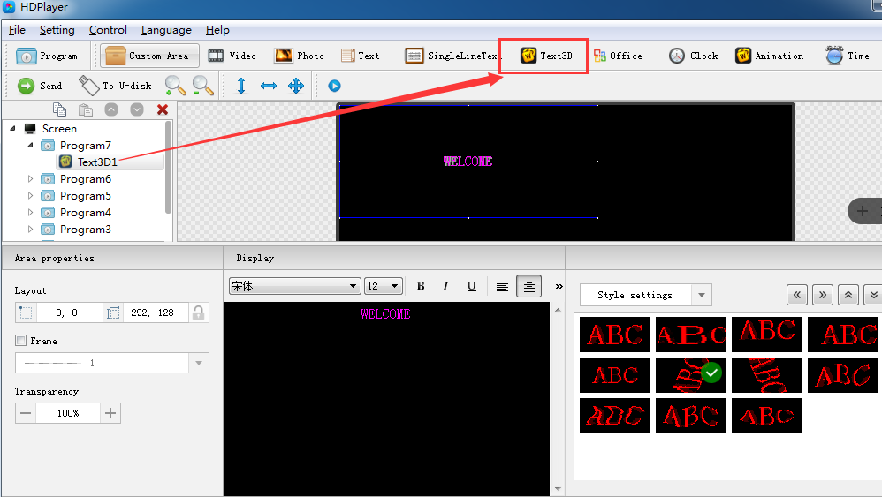
Fig. 3-37 Add 3D Text
1）3D Text Attribute 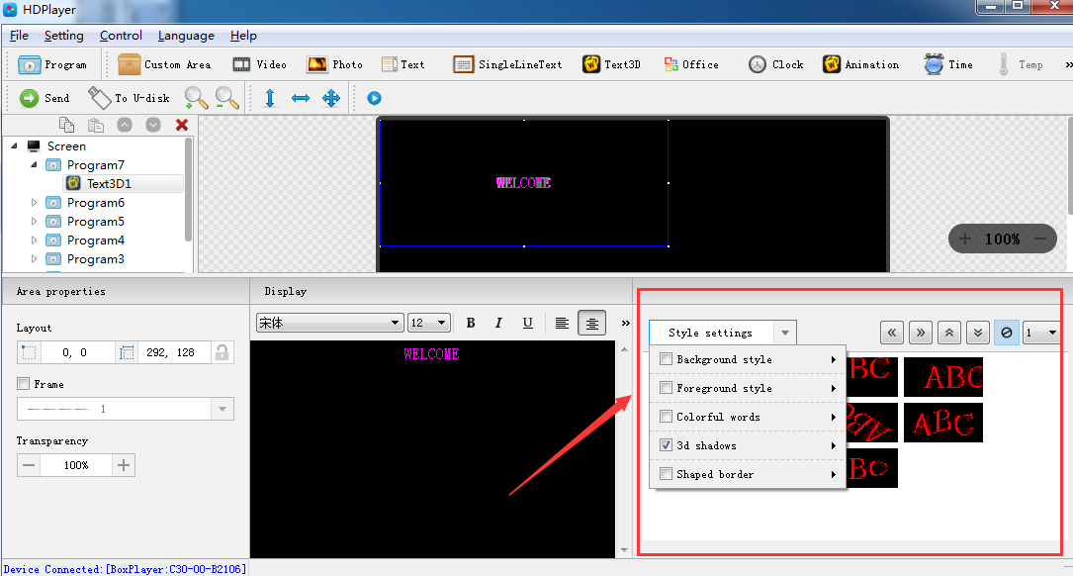
Fig. 3-38 3D Text Attribute

18. Add Weather
Click “Weather” icon to add weather; click “delete” button to delete it.
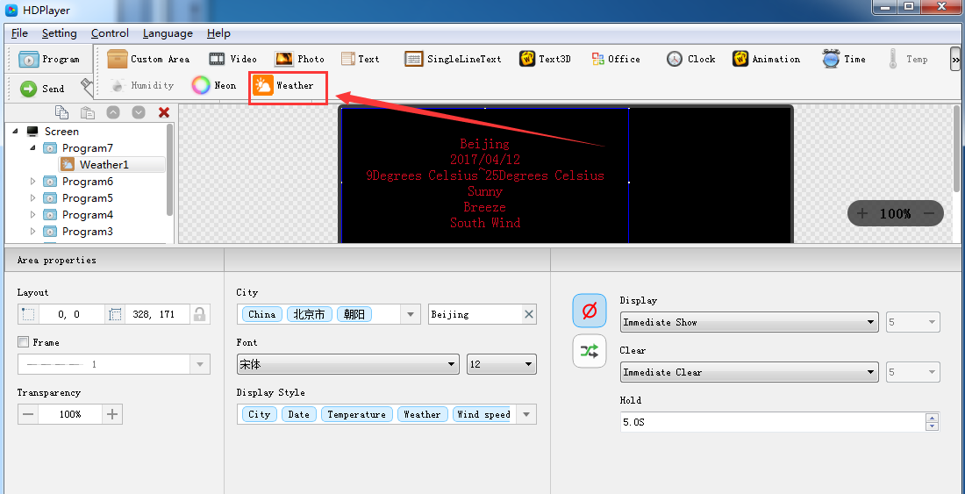
Fig. 3-39 Add Weather
1）Weather Attribute
Users can modify city weather and set the font, display type etc.
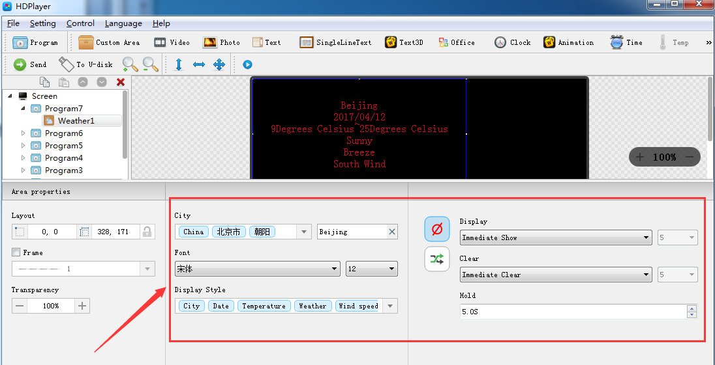
图3-40 Weather Attribute
Notice: above functions can also be added on custom area.

Chapter 4 Program Update
After finishing editing, the contents can be sent to the screen and will be showed on screen. The control card support updating programs through network and U-Disk. Meanwhile, it supports U-disk to expand memory limitless.

1. Network Cluster sending
Before sending the program, connect screen and control card by steps: 【control】→【devise Bind】. When connect screen with multiple card, program will send to all cards simultaneously (cluster sending); when connect multiple screens with one card, ongoing program will be replaced by later sending program.
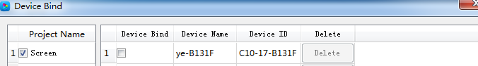
Fig. 4-1 Devise Bind
Click 【Control】→【Cluster sending】or click sending button on tool bar, program will be sent to the associated card.
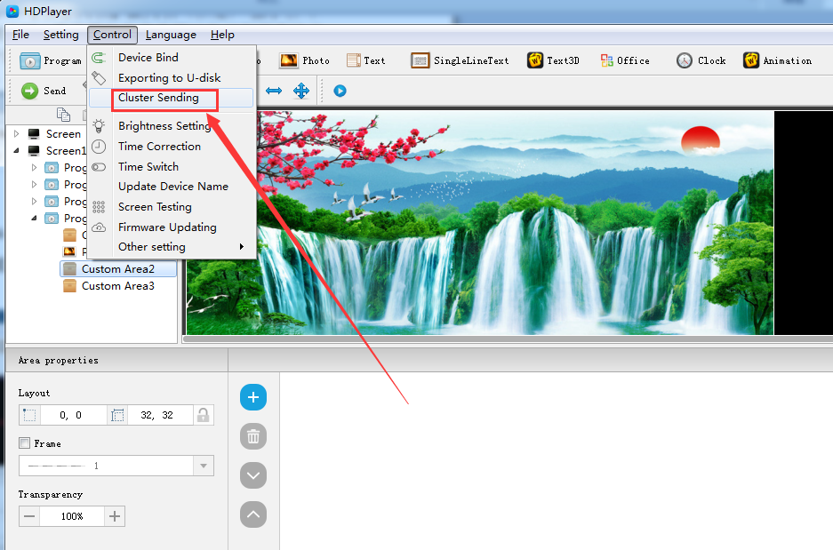
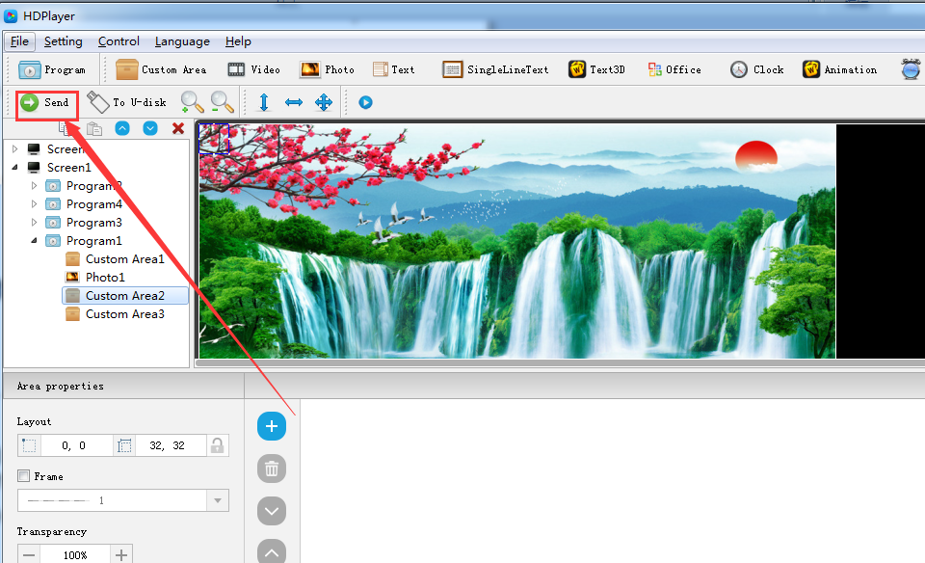
Fig. 4-2 Network Cluster sending

2. Update program by U-Disk
Plug U-Disk into PC, click 【control】->【export to U Disk】or click Export to U-Disk on tool bar, choose “Update Program”, programs will be exported into U-Disk.
Plug U-Disk into control card, program on U-Disk will be copied to the card’s storage board; screen will come out the tips.
Take away the U-Disk after copy. Screen will display the new program. Repeat same operation when renew program.
USB extension cable should be within 5m.
 
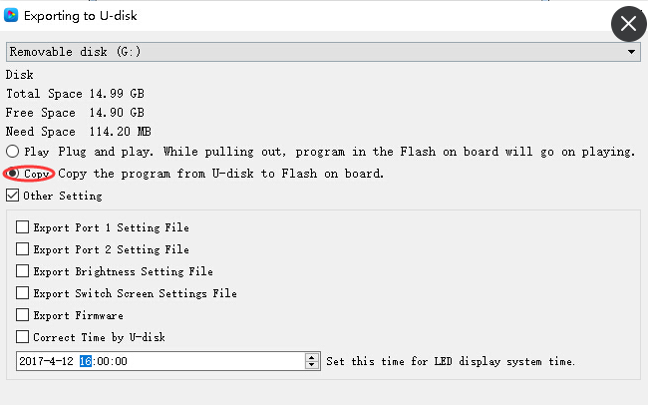
Fig. 4-3 Update program by U-Disk

3. 2. U-Disk expand memory Limitless
Choose “Display” after exporting program to U-Disk. Control card will display contents on U-Disk after inserting U-Disk into card. (No need to restart computer, program will begin display once inserting U-Disk into card). By this way, users can extend programs contents according to memory of U-Disk.
5m USB extension cable also support for U-Disk Display.
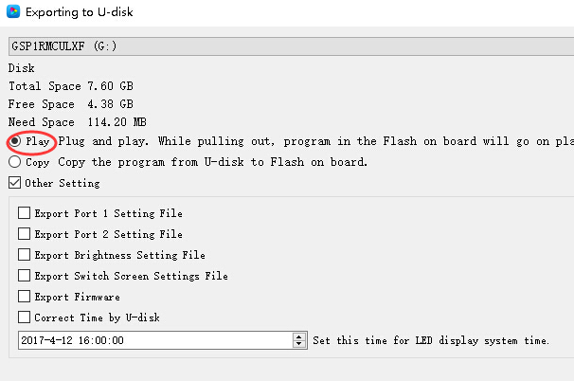
Fig. 4-4 U-Disk expand memory Limitless

Chapter 5 System Setting
Click 【setting】->【system setting】, it has saving warning, delete warning, using password, automatic log on setting.
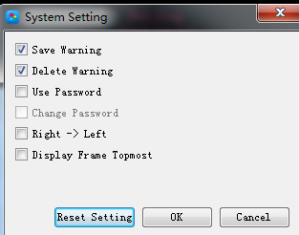
Fig. 5-1 system setting
Saving warning：
When tick it, saving warning will pop out when exit the software; or else, software will save automatically without warning.
Delete warning：
When tick it, delete warning will pop out when exit the software; or else, software will delete automatically without warning.；
Using password：
When tick it, users will need to input password to enter “hardware setting”、“firmware upgrade” or cancel password; Or else, software will regard user as administrator thus no need to input password.
Default password is “168” or “888”.

Chapter 6 System Control
In Software, click “Control”, and it include below total 9 functions:
(Device bind, Boot screen, Brightness setting, Time correction, Cluster sending, Export to U-disk, Screen testing, Firmware updating, Device network information).

1. Device bind
It means the relationship between the display and the sending controller. Bind the controller together with display, programs on screen will be sent to controller.
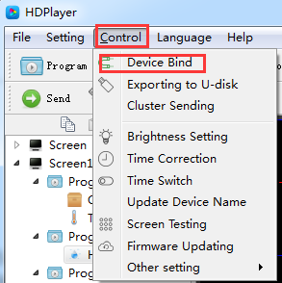
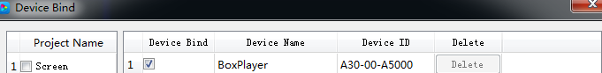Fig. 6-1 Device Bind
Users can bind multiple controllers with one screen, and can also bind multiple screens with one controller.

2. Brightness setting
After connecting device, choose controller ID and network port so that can adjust brightness. “Network port 1” adjust brightness of port 1, “Network port 2” adjust brightness of port 2.
When connected the sending controller ID, at the left bottom left shows tip “Got brightness successfully”, then can start setting.
Three types of brightness setting for choice: 1. Brightness setting; 2. Brightness setting according to time; 3. Brightness setting according to environment.

- Default Brightness Adjustment
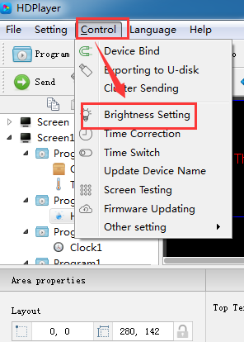
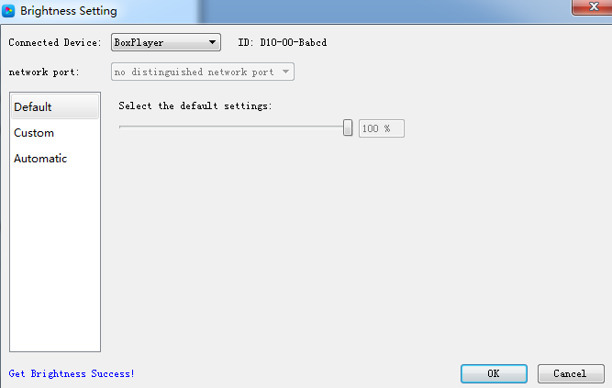
Fig. 6-2 Default Brightness Adjustment
2) Custom brightness
Tick it after setting the time and brightness and then click “ok”, on left bottom will see tip “set successfully”, it means save in controller. Choose Adding option can have multiple setting for user-defined data range. The defaults are three user-defined options.
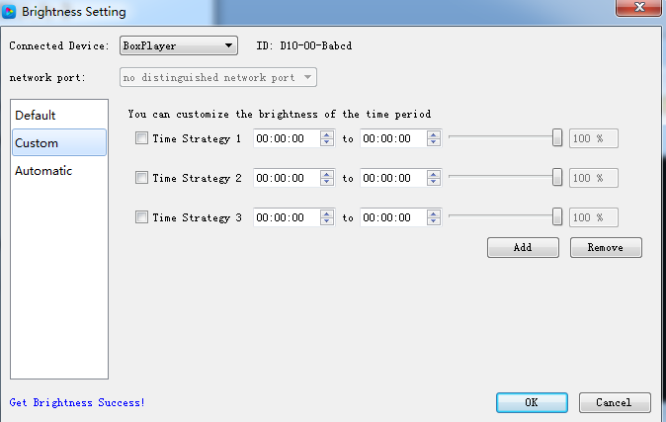
Fig. 6-3 Custom brightness
3）Automatic Adjustment
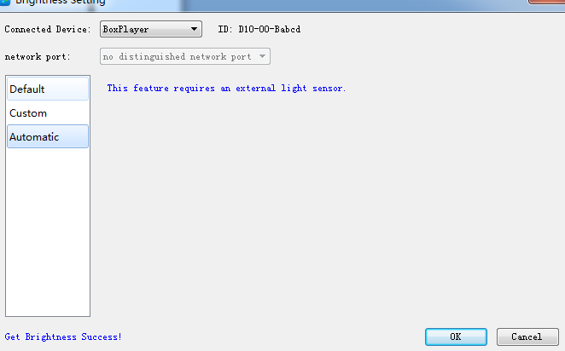
Fig. 6-4 Automatic Adjustment
Note：The brightness must have an external brightness sensor for automatic adjustment, otherwise this function is invalid.

3. Time Correction
After connecting device, choose ID of the controller that need to correct time. On left bottom will show a tip “get time successfully” then can start time correction. System will adjust time automatically according to time zones setting by computer and controller.
1）Synchronous Correction
Time will be synchronous with computer time. Choose option “OK”, on left bottom will show “Set Successfully”, means set successfully.
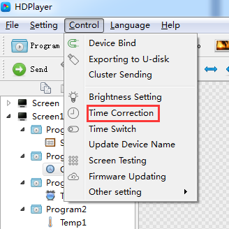
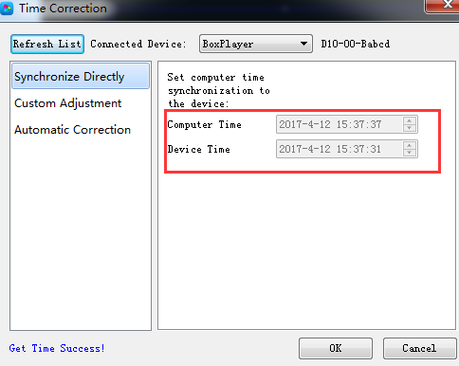
Fig.6-5 Synchronous Correction

2) Custom adjustment
Choose option “OK” after time setting, on left bottom will show “Set Successfully”, means set successfully.
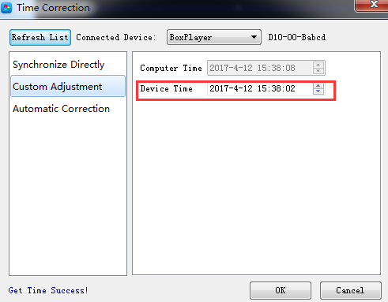
Fig. 6-6 Custom adjustment

4. Screen Testing
The system support gray scale test, color lump test, mesh test, spot test etc, so users can check lamp working situation of the screen.
Choose device ID, after see tip “connect successfully”, start screen test. Press button “TEST”（SW1）on control card to start screen test is also OK.
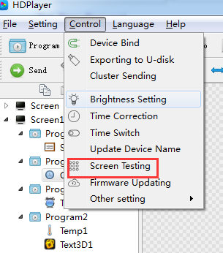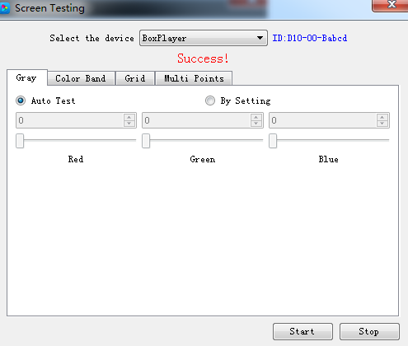
Fig. 6-7 Screen Testing

5. Firmware Update
Updating firmware, all firmware of the connected controller will be updated. Users should add new version firmware, compare its version number with the one with the connected controller, click button “Upgrade” if need to upgrade.
Whole upgrading procedure will be finished by software in backstage. After successful upgrade, users will see new firmware version, means the controller can be used normally. (Tip: do not cut off power supply for controller during update).
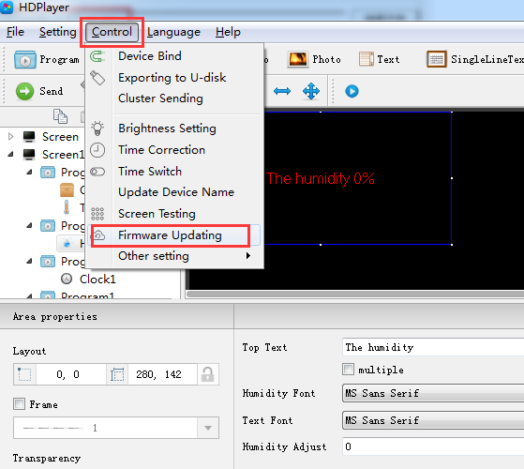
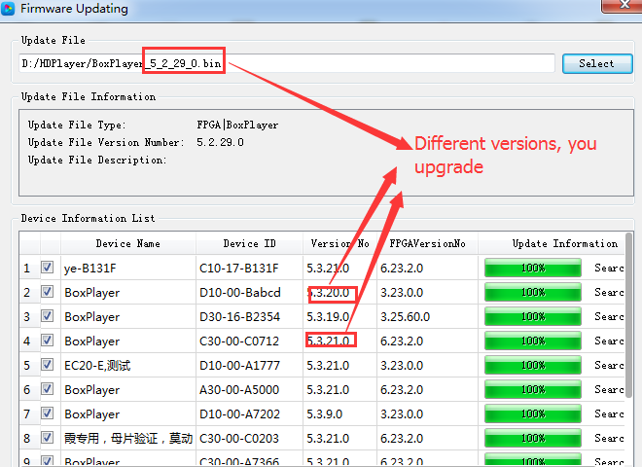
Fig. 6-8 Firmware Update

6. Network Information Setting
Two connections way are supporting: 1. Connect controller with computer; 2. Connect router with computer. No need to set IP for controller. If need to fix IP, click 【Control】→【set network information】for setting.
Obtain IP automatically: Click “set”→“use”→“set”.
Obtain IP manually: click “set”, do not tick “use”, then users can set controller IP and other network information. After setting, click “set”, then will obtain IP successfully. (Tip: use this function with caution. Setting IP needs to be in same network segment with computer’s local connection.)

